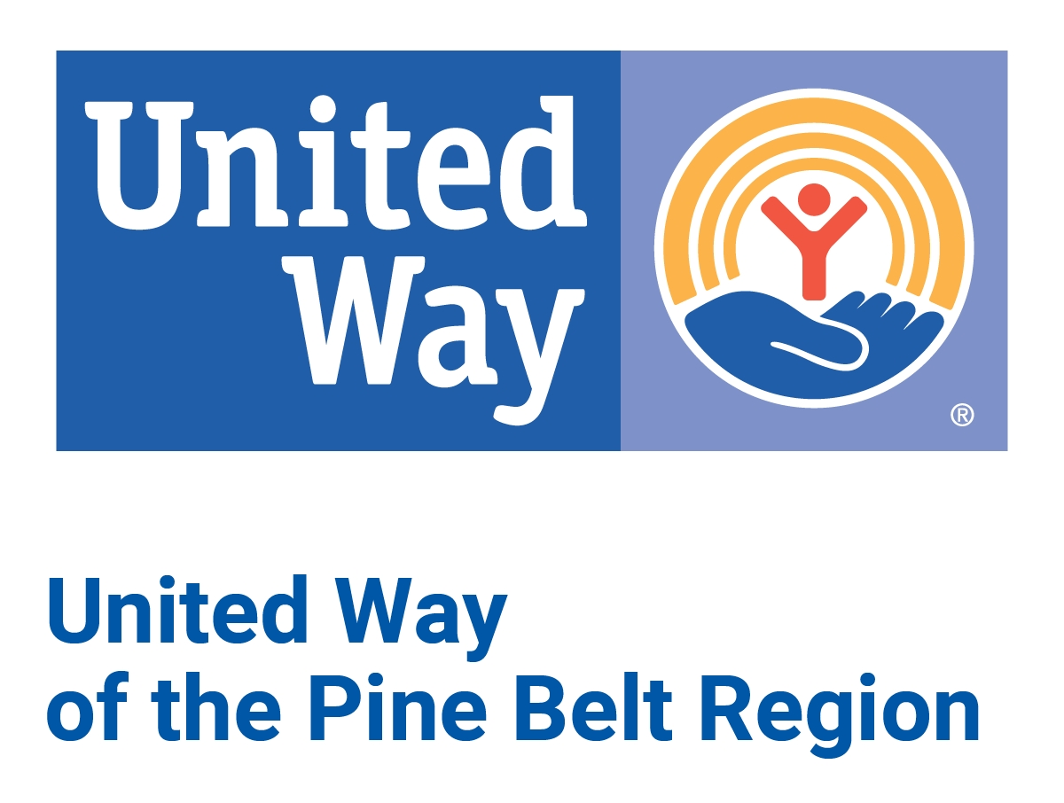
serving Covington, Jasper, Jones, Smith, and Wayne counties

Annual Application for 2026 Funding

Agency: _________________________________________________________________

Mailing Address: _________________________________________________________

Physical Address (if different from mailing): ________________________________________

Office phone: _____________________________

Contact Person: _______________________________Title: _______________________

Cell phone: ________________________ Website: _______________________________

Contact Email: ____________________________________________________________

Agency Email: ____________________________________________________________

Second Contact Person:________________________Other phone:___________________

Funding request for fiscal year January 1, 2026 to December 31, 2026

This packet was reviewed and approved for submission to United Way of the Pine Belt Region by:

__________________________________________________________Date: __________________
Signature--Agency Director
Please print name of signer_________________________________________________

_________________________________________________Date: __________________

Signature--Agency Board President (or equivalent officer)
Please print name & Title___________________________________________________

Agency Summary Information

- What is the agency’s mission?

- What programs are regularly provided by the agency? Please list in order of priority.

- Who is your primary target population (age, gender, common situation, income level, etc.)?

4 . How are agency services assessed for effectiveness?

5. How does this agency’s content vary from similar programs offered by other organizations in your service area?

6. Does the agency have a sliding fee scale for services to clients based on their ability to pay?

7. What new or different programs/services does the agency plan to provide in the year 2025? How will these new or different programs/services be financed?

8. What supplementary fund-raising activities does the agency conduct? Please list specific dates for any major fund-raising activity, net dollars raised, area covered, and anticipated goal for the fund-raiser.
Add supporting documents if needed.

9. Please provide, as accurately as possible, a count of all individuals directly served by your agency: (Note-this does not include billboards, media advertisements or brochures left in public places)
in 2023: ________________ (actual)

in 2024: ________________ (actual)

in 2025: ________________ (projected)

10. What primary age groups did you serve during 2024? Check all that apply.

______ Infants and toddlers _____ Young adults

_____ Children under age 12 _____ Adults

_____ Youth/teenagers _____ Older adults

11. Please estimate the number of individuals you served in the following counties during 2024. County total should include city residents. Please be as specific as possible. The UWPBR has to report this information.

______ Covington County

______ Jasper County

______ Jones County

______ Smith County

______ Wayne County

12. Ethnic analysis - Please estimate the individuals (by number or percentage) served by your agency in 2024:

______ Caucasian

______ African American

______ American Indian

______ Hispanic

______ Other

13. Please estimate the individuals (by number or percentage) with disabilities served by your agency in 2024:

Hearing _______ Learning_______

Physical _______ Visual _______

Mental _______ Multi _______

14. How long has your agency been in existence?

15. How long has your agency received funding from United Way of the Pine Belt Region?

16. What percentage of your agency’s budget does United Way funding represent?

17. What percentage of your agency’s budget is spent on administrative expenses?

18. Specifically, what percentage and dollar amount from your budget represents the services provided to the community?

19. How would the community be affected if your agency did not receive United Way funding?

20. Is your agency required to obtain an annual charity renewal status with the MS Secretary of State’s office?

If so, please provide a copy of your most recent charity renewal certificate.

21. Please provide documentation showing 4 examples of your agency’s affiliation with the UWPBR as a partner agency. This is a requirement in your MOU. For example: screenshot from agency website, screenshot from social media posts, agency signage, banners, letterhead, print media, etc.

